Predicting Order Profitability from Sales Data
Task 2 Report

1. Objective
The goal of this task was to build a baseline supervised-learning model on the same sales dataset used in Task 1, following standard practice: define the problem clearly, split the data correctly, preprocess the features without leaking information, train a baseline model, evaluate it with appropriate metrics, and honestly explain its limitations.

2. Problem Framing
Task 1 found that 50.8 percent of all order lines lose money. Given that, the useful question for the business is not how much an order will sell for, but whether it will be profitable at all. The problem was therefore framed as binary classification, with the target Profitable set to 1 when Profit is greater than zero and 0 otherwise.
The two classes come out almost perfectly balanced at 49.2 percent profitable against 50.8 percent not. That is convenient: accuracy is a fair metric here and no resampling or class weighting is needed. It also sets a clear bar, because a model that always guesses the majority class would score 50.8 percent, so anything useful has to beat a coin flip by a real margin.
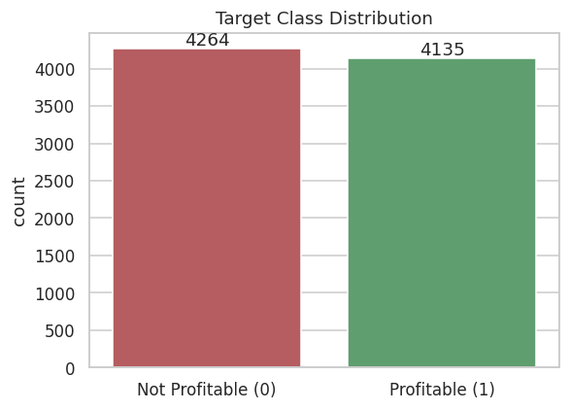
Figure 1: Distribution of the target class

3. Feature Selection
Profit was dropped because the target is derived from it, and keeping it would leak the answer straight into the model. ID columns and free-text names were dropped because they carry no generalizable signal, and the raw date columns were dropped because Shipping Delay already captures the useful part.
Group | Columns
Numeric (7) | Order Quantity, Sales, Discount, Unit Price, Shipping Cost, Product Base Margin, Shipping Delay
Categorical (7) | Order Priority, Ship Mode, Region, Customer Segment, Product Category, Product Sub-Category, Product Container
Dropped | Profit, Row ID, Order ID, Customer Name, Product Name, Province, Order Date, Ship Date

After one-hot encoding, the 14 input columns expand to 54 model columns.

4. Methodology
- Re-applied the Task 1 cleaning steps so the notebook runs standalone.
- Created the binary target and checked the class balance.
- Split the data 80/20 with stratify set to the target and a fixed random_state of 42, giving 6,719 training rows and 1,680 test rows with identical class balance in both.
- Built a ColumnTransformer applying StandardScaler to numeric columns and OneHotEncoder to categorical columns, wrapped inside a scikit-learn Pipeline.
- Trained Logistic Regression as the baseline model.
- Evaluated with accuracy, precision, recall, F1, ROC-AUC, a classification report, a confusion matrix and an ROC curve.
- Trained a shallow Decision Tree with max_depth of 5 on the identical pipeline as a comparison.
- Ran 5-fold cross-validation on both models to check the scores are stable.
- Inspected the logistic regression coefficients and tested the model on two new, unseen orders.
Keeping the preprocessing inside the Pipeline matters. It means the scaler and encoder are fitted on the training data only and then applied to the test data. Doing it manually before the split would leak test information into training and inflate the scores.

5. Results
Metric | Logistic Regression | Decision Tree (depth 5)
Accuracy | 0.7929 | 0.8685
Precision | 0.8028 | 0.8704
Recall | 0.7678 | 0.8609
F1 Score | 0.7849 | 0.8657
ROC-AUC | 0.8657 | 0.9296

Both models comfortably beat the 50.8 percent majority-class baseline. The Decision Tree outperforms the linear baseline on every single metric, which is itself a finding: it says the relationship between the features and profitability is not linear, so a straight decision boundary cannot capture it fully.
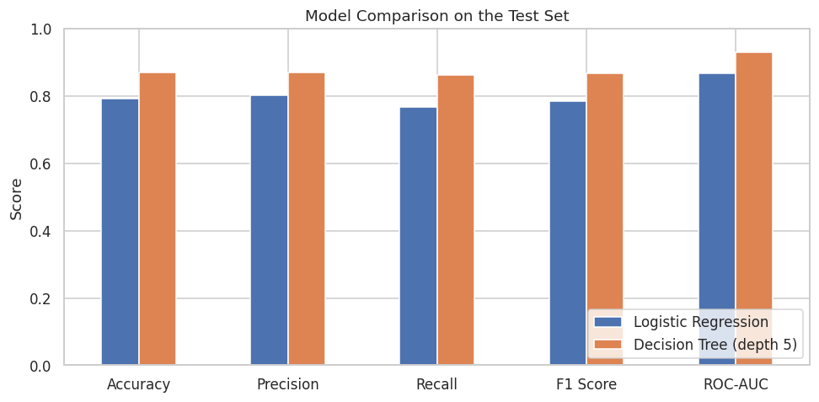
Figure 2: Model comparison across all five metrics

6. Confusion Matrix and Error Analysis
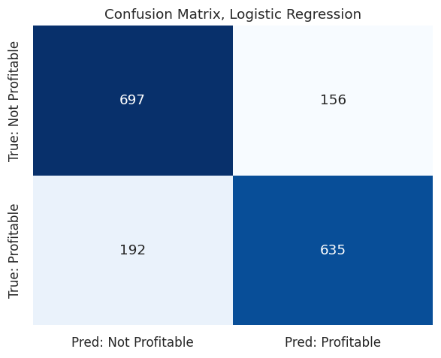
Figure 3: Confusion matrix for the logistic regression baseline
On the 1,680 test rows the baseline model produced 697 true negatives, 635 true positives, 156 false positives and 192 false negatives. The 156 false positives are orders the model called profitable that actually lost money, which in business terms means approving a deal that ends up in the red. The 192 false negatives are profitable orders the model flagged as losses, which means turning away good business. The two error types are roughly balanced, matching the balanced precision and recall.
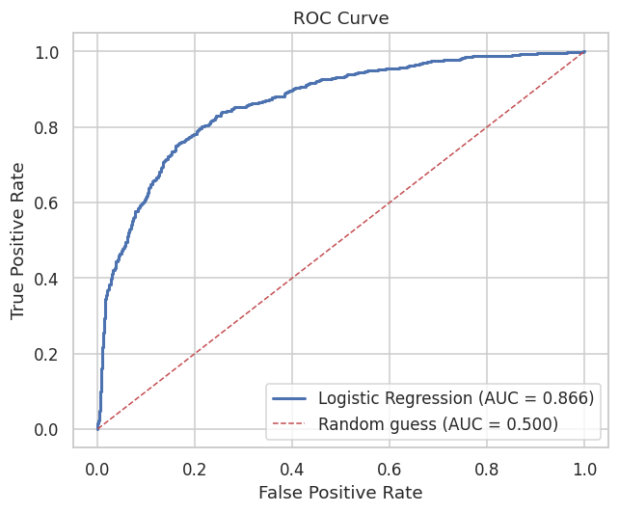
Figure 4: ROC curve for the baseline model, AUC 0.866
The ROC curve sits well above the diagonal with an area under the curve of 0.866, confirming the model separates the two classes far better than random guessing across every threshold.

7. Cross-Validation
A single train/test split can be lucky, so 5-fold cross-validation was run on the training set.
Model | Mean Accuracy | Standard Deviation
Logistic Regression | 0.7875 | 0.0070
Decision Tree (depth 5) | 0.8464 | 0.0130

Both cross-validated means sit close to their single-split scores with a small standard deviation, so the results are stable and not an artifact of one convenient split.

8. Feature Influence
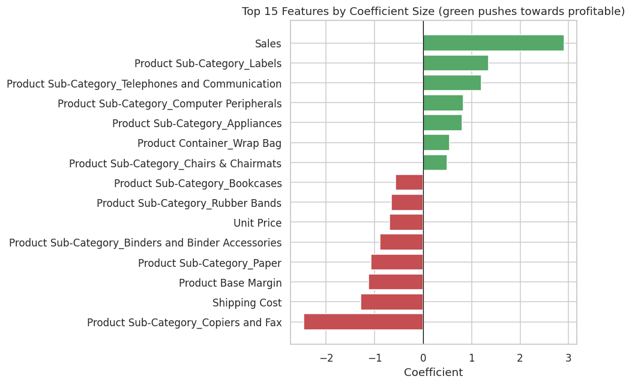
Figure 5: Top 15 logistic regression coefficients, green pushes towards profitable
Sales value is by far the strongest push towards a profitable classification, with a coefficient of 2.91. Shipping Cost and Product Base Margin push the other way, towards a loss. Beyond those, much of the remaining signal is carried by Product Sub-Category, with Copiers and Fax pushing strongly towards loss and Labels and Telephones pushing towards profit. This lines up neatly with the Task 1 finding that profitability is very uneven across sub-categories, which is a good sign that the model is learning something real rather than noise.

9. Prediction on New Orders
The trained model was tested on two hand-built orders it had never seen. A small, cheap, low-discount office supplies order was predicted NOT PROFITABLE with a 26.33 percent probability of profit, while a large furniture order shipped by truck was predicted PROFITABLE at 88.36 percent. This confirms the pipeline handles raw, unseen input end to end without manual preprocessing.

10. Limitations
- No cost-of-goods data. The dataset has no cost column, so the model can only infer profitability from price, discount and shipping. That is a hard ceiling on how accurate it can ever get.
- Row-level rather than order-level data. Each row is a product line, and lines from the same order share a customer and a date, so the random split can put two lines of one order on opposite sides of the train/test boundary. That is a mild form of leakage.
- The random split ignores time. Real forecasting would train on earlier years and test on later ones, whereas this split shuffles all four years together.
- No hyperparameter tuning. Default settings were used throughout apart from capping the tree depth. This is deliberate for a baseline, but it means neither model is performing at its best.
- The decision threshold is fixed at 0.5, even though the business cost of approving a losing order is almost certainly different from the cost of rejecting a good one.
- Logistic regression can only draw a straight decision boundary, which is exactly why even a shallow tree outperforms it here.

11. Key Lessons and Improvements for the Next Iteration
- Group the split by Order ID using GroupShuffleSplit so no single order is spread across train and test.
- Try a time-based split, training on 2009 to 2011 and testing on 2012, which matches how the model would actually be used in production.
- Add engineered features such as revenue per unit, shipping cost as a share of sales, and order month, which are likely stronger signals than the raw columns.
- Tune the decision threshold against a real cost matrix instead of leaving it at the default 0.5.
- Once the baseline is solid, move to an ensemble such as Random Forest or Gradient Boosting and compare it fairly against these numbers.
- Log every experiment's metrics in one table so that improvements are measurable rather than assumed.

